**Empowering Communities through Accessible Learning for Person with Visual Impairment and Digital Skilling for Women**

Project Proposal by

WinVinaya Foundation

To

AECOM

Date of Proposal: 9th August 2024

Version 1.0

Project Contact: Helen Mary K I

Senior Project Coordinator

WinVinaya Foundation

25/3 Brindavan 3rd Cross, Saraswathipuram IIM Post

Bengaluru 560076

Ph.: +91-96764-33359

Email: [info@WinVinayaFoundation.org](mailto:info@WinVinayaFoundation.org)

**Introduction of WinVinaya Foundation**

WinVinaya Foundation is a Charitable Trust whose primary aim is to empower Persons with Disabilities, economically disadvantaged, women and transgender people to lead a life with dignity by providing life skills and resources. We cater to 18 different disabilities out of 21 disabilities recognized by Govt. of India and have trained 1440+ candidates (Persons with Disabilities, Women) hailing from 24 states of India – in Full Stack Software Development, Software Testing and Test Automation, Microsoft Power BI, Core Banking, Financial Accounting, and Accessibility Testing skills which help them to get into high-end job roles. To date, we have placed 440+ candidates in various MNCs and MSMEs. For a detailed breakdown of the job roles our candidates have secured, including those from diverse backgrounds, you can explore our interactive.

For more information about the WinVinaya Foundation visit: <https://winvinayafoundation.org/>.

**Project Overview**

We are pleased to provide multiple project options that AECOM can consider for amplifying the social impact.

| **Project** | **Project Description** | **UN SDG’S Goals** | **Beneficiaries** | **Social Impact** | **Budget (in ₹)** |
| --- | --- | --- | --- | --- | --- |
| **Remediation of Books for Students with Visual Impairment** | Converting non-accessible textbooks into accessible formats which will be beneficial for persons with visual impairment. | * Quality Education (UN SDG: 4) * Reduced Inequalities (UN SDG: 10) | Persons with Visual Impairment | * Digital literacy boosts employability and independence while accessible learning materials bridge educational gaps for visually impaired students. | **₹ 7** **Lakhs** |
| **Empowering Women: Comprehensive Digital Skills Training** | Empower 50 women with Digital skills | * Quality Education (UN SDG: 4) * Reduced Inequalities (UN SDG: 10) * Decent Work and Economic Growth(UN SDG 8) | Women | * Enhanced Career Opportunities * Increased Economic Independence * Reduced Gender Disparities | **₹ 8** **Lakhs** |

## Refer to Appendix 1 for more information about the UN SDG’s.

# **Project 1 – Remediation of Books for Persons with Visual Impairment**

**Project location:** Bengaluru

## **Background / Problem Statement**

Students with visual impairments face significant challenges accessing traditional learning materials, hindering their ability to learn independently and take exams. They often depend on sighted friends or scribes to read materials and write exams, which severely hinders their learning progress when scribes are unavailable. By providing these students with books that are searchable, easily navigable, and audible, they can independently learn at their own pace and on their own schedule. This would grant them the same learning freedom as those without visual impairments. Additionally, digitized books can be easily shared across the entire community. WinVinaya could offer digital remediation services for printed or scanned books, converting them into accessible PDF and audio formats.

**Digital Remediation for Printed/ Scanned STEM/ Other Books to PDF and Audio Formats**

The students with visual impairment encounter unique challenges when engaging with STEM (Science, Technology, Engineering, and Mathematics) textbooks and other books and documents due to the heavy reliance on visual elements and complex concepts.

Some of the specific accessibility challenges include:

* **Visual Diagrams and Graphs:** Understanding complex diagrams, graphs, and charts is crucial in STEM subjects. Visually impaired students cannot interpret these elements directly, hindering their comprehension.
* **Mathematical Equations and Formulas:** Comprehending mathematical equations and formulas written in standard print is difficult without visual cues. Braille translations can be complex and time-consuming to produce.
* **Access to Specialized Equipment:** STEM subjects often involve specialized equipment like microscopes, calculators, and computer software. Ensuring accessibility to these tools for visually impaired students can be a significant hurdle.
* **Limited Availability of Accessible Textbooks:** STEM textbooks are often not available in accessible formats like braille or electronic text with appropriate alternative text descriptions.

Hence, it is critical to convert the books into accessible format to empower visually impaired students, fostering independence, knowledge acquisition, and equal educational opportunities.

## **Objectives**

* **Accessible Learning Content:** The project will convert existing textbooks into accessible EPUB format. This conversion allows visually impaired students to access their study materials independently using digital devices equipped with assistive technologies.

## **Target Beneficiaries**

WinVinaya will collaborate with schools and colleges to Remediate the textbooks which will benefit the whole community who would be able to access the remediated books. We are targeting at least **100 students with visual impairment** as beneficiaries.

## **Activities and Methodology**

At a high level, we will be remediating textbooks, and reference books.

Our approach to document remediation involves the following steps:

1. **Scanning:** If the document is a physical copy, the documents will be scanned page by page and PDF file will be created.
2. **OCR:** Optical Character Recognition (OCR) is performed on the scanned documents. We will get the unformatted plain text as the output of this step.
3. **Proof Reading:** We check the document content for text, links, images, tables, graphs, headings, etc., based on the original document and correct as per the same.
4. **Remediation:** We provide alternative text descriptions for images, proper heading structure, modify unreadable fonts or color combinations, and update the tables or complex layouts. We set the reading order, add tags, and format the document accordingly for accessibility.
5. **Final Validation and Deliver:** The final validation for the accessibility is performed by the Persons with Visual Impairment and converted to PDF format.

## **Benefits:**

The benefits of using the remediated books:

**Overcoming Reading Difficulties:**

* **Text-to-Speech Conversion:** Converting written content into audio format allows students to access information independently.
* **Structural Tags:** Adding structural tags to digital documents improves navigation, allowing students to easily locate specific sections.
* **Digital Bookmarks:** Creating digital bookmarks and hyperlinks enhances the ability to move between different parts of a document efficiently.
* **Improving Access to Visual Information:**
* **Alternative Text:** Providing detailed descriptions of images, diagrams, and graphs through alternative text makes visual information accessible to screen reader users.

**Ensuring Compatibility:**

**Adherence to Accessibility Standards:** Following guidelines like WCAG ensures documents are compatible with assistive technologies.

By implementing document remediation practices and providing the accessible books and documents, the educational institutions can significantly improve the learning experience for visually impaired students in STEM and create a more inclusive environment.

## **Output & Outcome**

As part of this project, we are planning to remediate 10 textbooks that include both STEM and non-STEM books. These books will be shared with the inclusive institutions for better reach of more beneficiaries.

Remediated books significantly enhance the lives of visually impaired individuals by offering several advantages.

* They provide **equal access to information** and knowledge, fostering **independence** and **inclusivity**.
* These books contribute to **improved literacy rates** and **educational attainment** among the visually impaired population.
* Remediated books can boost **self-esteem** and **confidence** by empowering individuals to learn independently.
* They facilitate **lifelong learning** and personal growth, opening doors to various opportunities and career paths.

## **Cost Estimates**

The estimated cost for implementing the “**Remediation of Books for Persons with Visual Impairment**” project is **₹ 7 Lakhs**.

|  |  |  |  |
| --- | --- | --- | --- |
| Project Activity | No. of Books | Cost Per Page | Total Cost |
| Remediation of the school/college textbooks/reference books | 10 books(Approximately 4000 pages in total) | ₹ 175 | ₹ 7,00,000 |
| Total | | | ₹ **7,00,000** |

## **Summary**

The **Remediation of Books for Persons with Visual Impairment** program empowers students with visual impairments to become active participants in the digital world. Your contribution will make a significant impact on the lives of persons with visual impairment, preparing them for a bright and independent future.

# **Project 2 – Empowering Women: Comprehensive Digital Skills Training**

**Project Location:** Bangalore, Karnataka and Tiruppur, Tamil Nadu

## **Background / Problem Statement**

India's population is over 1.4 billion, with approximately 48.42% being female, which translates to around 678 million women. Many women face challenges in securing suitable employment due to a skill gap between industry demands and their abilities.

WinVinaya believes that women deserve better opportunities and aims to engage with them early, providing targeted interventions for a brighter future. Acting as a mentor, WinVinaya focuses on upskilling women for employment, bridging gaps, and delivering niche, industry-ready training that meets employers’ needs. By addressing these issues, WinVinaya promotes gender equality and creates inclusive training programs tailored to women’s specific needs. This involves closing the skill gap, eliminating biases, providing education and training opportunities, and establishing support systems to empower women for successful careers.

## **Objectives**

To identify deserving women and train them in niche technologies as per the industry needs along with Communication skills and soft skills, fill the gaps between what the industry expects and what the candidates possess and place them in inclusive companies.

1. **Bridge the Skill Gap**: Equip women with niche, industry-ready skills.
2. **Promote Gender Equality**: Empower women and eliminate biases and discrimination in the workforce.

## **Target Beneficiaries**

50 Women candidates will directly benefit from this program and will be trained in industry-ready skills.

* Young women aged 18-35 years with limited access to higher education or employment opportunities.
* Women from rural and underserved areas.

## **Activities and Methodology**

#### **Sourcing of Candidates**

WinVinaya will mobilize 50 Women candidates. The candidates will be primarily freshers looking for a job, across different educational backgrounds (Any Graduation, Diploma & 12th Std.)

#### **Pre-Training assessment & Career Counselling**

WinVinaya will conduct an assessment for the shortlisted candidates to choose the appropriate training methodology, duration and make it more effective as per the skill of the candidates. WinVinaya will also do career counseling sessions for each candidate to understand the interests of the students and map them to related roles.

#### **Training & Skilling**

Training in WinVinaya Foundation will be holistic and includes quality Training in Technical/Domain, Soft Skills, English Communication which will help them gear up in this era of globalization and instill in all candidates the hunger to learn more and learn it right.

WinVinaya will provide Training in Digital skills – Basics of MS Word, MS Excel, MS PowerPoint, Introduce Gen AI and Prompt Engineering, Typing Skills and Soft skills. WinVinaya will also be using WinVinaya Academy, presentations, videos, and audios for providing the training. Refer to Appendix -2 for details on the curriculum.

Training curriculum includes theoretical sessions, assignments, case studies and practices. Refer to Appendix – 3 for more information about the WinVinaya Academy.

The duration of training for each batch is **6 weeks**.

#### **Volunteering Opportunities**

The employees of AECOM are most welcome to volunteer and support our initiatives and enable women to lead a life with dignity. There are multiple ways in which volunteers can make a positive impact. During the training, two hours a week are assigned to conduct soft skills workshops, Mock Interviews, give speeches and seminars in various motivational, that will the candidates to prepare themselves to become job ready candidates.

## **Output & Outcome**

Empowering 50 women candidates with the digital skills would increase the chances of them getting job, enhance the earning potential, improved self-confidence and career aspirations, they can teach their children and community on digital skills which will benefit more indirectly, positive social impact and gender equality.

**Cost Estimates**

The estimated cost for implementing the **“Empowering Women: Comprehensive Employability Training for Career Advancement** “project is **₹ 8 Lakhs**.

|  |  |  |  |
| --- | --- | --- | --- |
| **Sl.No.** | **Cost Head** | **Cost per Head** | **Total Cost** |
| **1** | Mobilizing the 50 candidates | ₹ 2,000 | ₹ 1,00,000 |
| **2** | Training – Digital Skills | ₹11,000 | ₹ 5,50,000 |
| **3** | Project Management |  | ₹ 1,00,000 |
| **4** | Infrastructure Support |  | ₹ 50,000 |
| **Total** | | | **₹** **8,00,000** |

**Thank you**

We thank you for providing this opportunity to collaborate with you to create a more inclusive and digitally empowered society. We are confident that this initiative will make a significant impact on the lives of individuals and contribute to a more inclusive society. Your support in funding this project will enable us to provide essential skills training, empower women, and bridge the digital divide.

## **Appendix – 1: SDG Goals**

1. **Quality Education (SDG 4):**

* Revitalizing libraries and providing digital literacy training
* Providing access to WinVinaya Academy for diverse learners

1. **Gender Equality (SDG 5):**

* Empower Women and Transgender individuals by promoting gender equality in the workforce, this project contributes to achieving SDG 5.

1. **Decent Work and Economic Growth (SDG 8):**

* The project’s objective of facilitating direct interaction between trained candidates and employers aligns with SDG 8.
* It promotes sustained, inclusive, and sustainable economic growth by providing employment opportunities.

## **Appendix – 2: Course Curriculum**

1. **Introduction to GenAI and Prompt Engineering**

|  |  |
| --- | --- |
| **Sl. No.** | **GenAI Tools & Prompt Engineering Topics** |
| 1 | Introduction to Generative AI – Copilot, Gemini, Chat GPT, Perplexity |
| 2 | Prompt Engineering – How to create effective Prompts |
| 3 | Writing- Resume, Email, Getting suggestions. |
| 4 | Meeting Summaries, Action Plans and Notes. |

1. **Basics of MS Office**

|  |  |
| --- | --- |
| **Sl. No.** | **MS Office Topics** |
| 1 | **MS Word:**   Formatting Text & Paragraph,  Proofing Features,   Page Layout, Inserting TOC, Working with Tables & lists,  Inserting Illustrations - shapes, images, tables,   Print Settings, Export to PDF |
| 2 | **MS Excel:**  Introduction to Excel, Excel Basics, Merge & Wrap Text,  Format Cell in Excel, Fill Handle, Sort & Filter,  Conditional Formatting, Formulas and Calculation,  How to insert and delete row/column, Freeze panes,  Hyperlink, Charts in Excel, IF Function, Modify Workbook Views,  Pivot tables, H Lookup & V Lookup,  Data Validation, Index & Match Functions,  Count Function, Text Functions, Date & Time Functions |
| 3 | **MS PowerPoint:**   Introduction to PowerPoint,  Presentation Basics,  Inserting Picture and videos,  Working with Tables,  Slide Effects - Transitions, Animations,  Export to PDF, Convert to video |

1. **Speed Typing**

|  |  |
| --- | --- |
| **Sl. No.** | **Speed Typing Topics** |
| 1 | Intro - Basics of typing, best practices |
| 2 | Fingering |
| 3 | Home rows |
| 4 | Top rows |
| 5 | Bottom rows |
| 6 | Numbers |
| 7 | Words practice |
| 8 | Sentences |

1. **Soft skills**

|  |  |
| --- | --- |
| **Sl. No.** | **Soft skills Topics** |
| 1 | Professional Etiquette & Behaviour |
| 2 | Art of Listening and Communication |
| 3 | Resume Preparation |
| 4 | Self-Advocacy |

## **Appendix – 3 WinVinaya Academy**

WinVinaya Academy (WVA) is India’s First Digital Learning Academy designed for students who are Persons with Disabilities where courses are available in **Indian Sign Language** and for women and people from rural background in **simple** **English** for understanding the concepts easily.

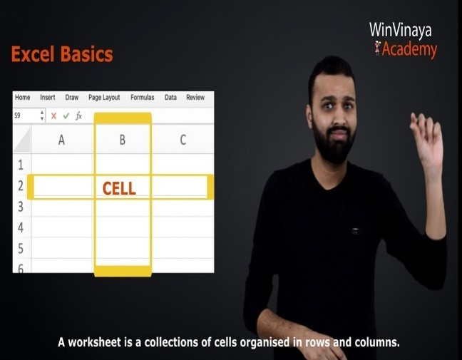

WVA has courses in English, Core Banking, MS Excel, MS Power BI, MS Teams, Full Stack Java Development, SQL, HR process and more to cater to STEM and non-STEM candidates.

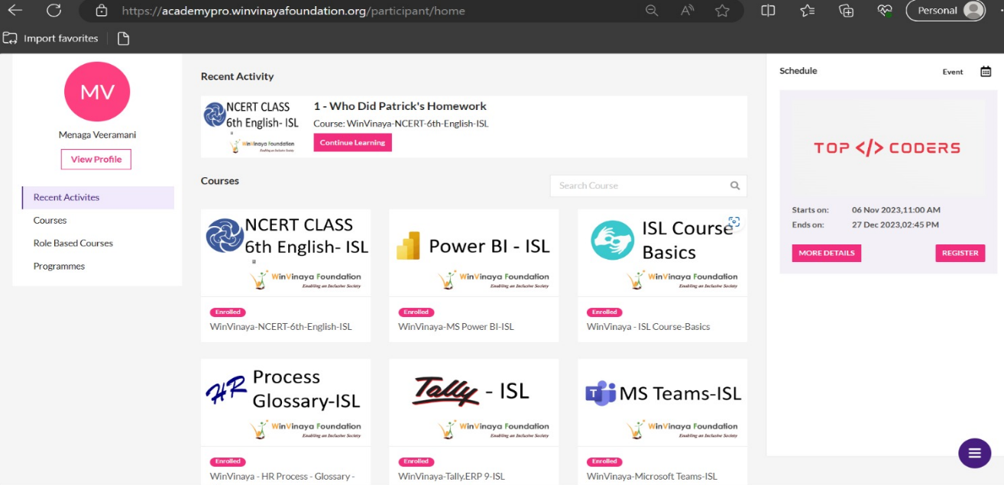

This platform is available on the cloud, so the candidates can learn anytime, anywhere. 90% of the course content is experiential learning with a lot of exercises aligned to industry needs.

**Every course has 3 modules –**

* i-Learn (with Micro Learning Videos)
* i-Practice (Hundreds of exercises with a combination of auto evaluation and expert evaluation)
* i-Assess (Exercises to be solved within a time duration like exams/ interviews)

This platform provides a code editor and an in-built compiler which is extremely useful for the candidates to practice software programs. These programs will be auto evaluated against the preloaded test cases (positive, negative, edge cases). This helps the candidates improve their coding skills and clearing the online programming tests conducted by most of the IT companies as part of their initial technical round.

In addition to direct coding practice, the academy provides different self-evaluation techniques like quizzes, code analysis, and such.

